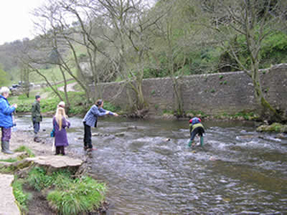
MANIFOLD MUSIC
Our current project, Rivers of Life, is inspired by the spectacular river landscape around Leek and combines expeditions to different river sites with creative workshops in various art forms, including music, writing and visual art.
This compilation of river sounds, music and words was inspired by the Manifold River and was produced by Torben Franck for Borderland Voices.
River sounds and images were captured on digital equipment at Wetton Mill and then transferred onto computers at the Warslow Online Centre. Later, participants recorded spoken words, singing and poetry to add to the soundtrack.
Torben Franck then edited, mixed and constructed the composition with added piano music by Marianne Forelius.
We embarked on our river journeys from the Manifold at Wetton Mill in April 2005. We aim to return to home base in Leek in the early autumn of 2006 for a final celebration and exhibition at the Nicholson Institute.
To purchase a copy of the CD, please email us at info@borderlandvoices.org.uk

